IOT DEVICES USER

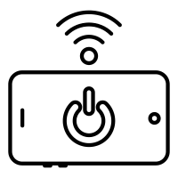 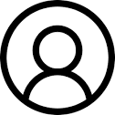

|  |
| --- |
|  |

IBM WATSON IOT PLATFORM NODE RED WEB UI

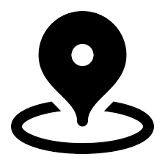 

GEO FENCE CLOUDANT DB